GemBerry
a User response application



GemBerry is a program that creates Web application, that can be defined by json files to represent parameters to build the application screens,
the application will collects data from users and saves in in a mysql DB as JSONs.
In this spec we defined a sample application that demonstrates the GemBerry functionality.
The current updated Code for this application will be kept in https://github.com/shaykid/GemBerry

Basic Data management
JSON files are kept in MySQL DB, and can be retrieved by their Object ID

DB name: hinbit_GemBerry
User: GemBerryDeveloper
Password: yHaYJZf99H%8
Table: OBJECTS

- When ever a program gets an Object ID, it can retrieves the relevant JSON from DB.
(i.e to get the last updated record of the requested Object ID
SELECT JSON
FROM OBJECTS
WHERE ID = 9900002001
ORDER BY UpdateTime DESC
LIMIT 1;
)

- If JSON parameters were changed during the program run (by user activity or any other trigger like time etc) the program will write the changes back to the table
(i.e If "MediaSets": { "Texts": { "Header" : "Default Page header to use" }} value was changed to 'a New Updated Header' we will use:

UPDATE OBJECTS
SET JSON = JSON_SET(JSON, '$.MediaSets.Texts.Header', 'a New Updated Header'),
UpdateTime = NOW()
WHERE ID = 9900002001
ORDER BY UpdateTime DESC
LIMIT 1;
)

Program Files in this sample
GemBerry-Object-List.json – Basic Object Definition for the program.
GemBerry-ScreenSequence.json – The Sequence of Screens to be “played”
GemBerry-User-Browse_Data.json – Holds user data collected via browser
GemBerry-1stScreen - 1st Screen
GemBerry-2ndSscreen-C1 - 2nd Screen
GemBerry-3rdScreen-C1 - 3rd Screen
GemBerry-4thScreen-C1 - 4th Screen
GemBerry-5thScreen-C1 - 5th Screen
GemBerry-6thScreen-C1 - 6th Screen

Program Actions
when program starts it needs to have a few elements

– the user: program should put a cookie on user device (if possible) to identify the user session and if possible identify the user next time he uses the program.
User can register (log) to program using Google/Facebook existing user.
Default behavior can be an anonymous user. (Not have to login)
User will be kept using an inner app user ID in a SQL table
table:USERS

- The Current Object-List acting as basic objects for current run. (i.e GemBerry-Object-List.json ) can be passed as parameter when intilize the app.
- The Sequence to start with.(i.e GemBerry-ScreenSequence.json )
can be passed as parameter when start the app. (in the app url)
- automatically retrieve user data json (appendix A) from the user device and save it in table:USER_BROWSE_DATA
- The Program will be responsive, adjusting itself to user device (note that this is also controlled by the "CanDisplay" key)
- Program will work by ScreenSequence file that can be passed as parameter when start the app. (in the app url).
- when user fills data in a screen, program will save the new data as updated key-values in the screen JSON and saves this updated json to DB.

Program Flow

- When program starts it gets as first param a json holding a ScreenSequence
(i.e http:://myq.re/developSamples/GemBerry-ScreenSequence.json) or its JSON ID.
according to "JSON_Version" value (i.e 1.8) it will upload the relevant GemBerry-Object-List.json that supports this version and below (so if JSON_Version in sequence = 1.8, it will require Object-List.json from version 1.8 or above) you can see sql code sample for this retrieving here

This will supply the basic object definitions for the program (these definition will be updated during program run, and the updated JSOn will be saved to DB) on which it will define each element we will use.
Than program will build the elemnts relevant per screen, it will use object hirerchy as detailed below to get the full set of params needed per element.
The program will use the ScreenSequence to determine the prev/next screen URLS.
Program will always transfer as parameters between screns the "CurrentUser", "CurrentSessionID", "ScreenSequence"."Object_ID". So all filled jsons per session of the same Sequence will hold the same set of IDs.
When user change a value of a page element (select, user text, image upload etc), the new value will be updated in the screen json
When page is exited (using the (X) button or Next button or end of page time)
screen "exitType" will be updated ("close, next, previous, time, unkown")
screen "PageState" will be updated to “filled”.
the updated screen json will be written to the DB.
The next Page (as defined in sequence) will be opened.

JSON definitions
General:
"CanDisplay" : "landscape" – this means the program will always treat the user device as its in landscape mode, regardless to how user holding it.
"portrait" - same with portrait mode
“user” – according to user (normal mobile behaviour)
"Screen-Rtl" : "rtl" - texts in this page should be aligned to right, "ltr" - texts in this page should be aligned to left. If no value default is “rtl”.
"PageTime" : "45" – number of seconds until page close itself, if "TimeRenew"=”true” the page second count will be reset to this number every time user “updates” and of the page values or selections.
"URLSet" – a set of URLs to be used in this page, can be reached when using the ^P reserved word.
"MediaSets" – all medias that can be used in page, includes "Texts","Images","Videos","Audios"
can be reached when using the ^P reserved word,
(i.e if a Button inside a page defines image "hover": "^Pnext-button-press-image" it will take the value from "MediaSets".”next-button-press-image”)

"Rserved_Words": { // a set of reserved words to be used in the program.
"^M": "https://myq.re/mamushka/qa/", // Default root for given URLs
"^I": "^M/ImageBank/", // Default root for images URLS
"^A": "^M/AudioBank/", // Default root for Audio URLS
"^S": "656522243", // Sequence number as parameter to URL
"^U": "000", // User ID that active in this sequence (will be altered by a user runs the program)
"^X": "?V=1.8&SID=^S&UID=^U" // the parameters extension to be added to all urls in page,
keep in mind program need to enter the json version (1.8) as the first param
“^D” : “000”, // User points default value of the Current page
“^Q” : “000”, // User current points value (updates along the way)
“^P” : “” , // a reserved word that indicates values in the current json, for example if prevButton.UrlToJump =”^PprevURL”, it means it will take the Value defined in the page element
URLSet.prevURL (i.e "^M//DefaultPrevUrl" )

When program starts a page it takes the relevant User data (User ID, User Point, User name etc..) and updates the relevant key-values in json.
Also update "PrevPageObjectID" & "NextPageObjectID"
program start countdown by "PageTime", then it reaches 0, it close the page (as next was pressed). If "TimeRenew" = “true” every time the user will press any element on page, time will be reset back to "PageTime" and countdown starts again.

"PageState" declares if its a new page "clean”, a page that user filled answer “filled” or “unknow"
"exitType" : describes how page was exited "close”, “next”, “previous”, “time”, “unkown"
"PrevPageObjectID" – the ObjectID from which we reached this page, in first page it will be “”.
"NextPageObjectID" – the ObjectID to which we jumped from this page.

When program ends a page it takes the updated json (with all added/changed params) and write it to the DB table OBJECTS_LOG by time, user ID, sequence ID and Object ID.
It also updates the user points by adding the current "PagePoints" to the user points.

ScreenSequence:
GemBerry-ScreenSequence - you can see updated json here and in Appendix S0
Current Keys definitions:

"URLSet": // a set of default URLS to be used in pages
"ScreensSet" // the screens participating in the Sequence.

program will get user ID from table:USERS and update the "^U" & “^Q” reserved word.
Program will build the "^X" reserved word by sequence and user IDs

Program will take the first Screen ID in the set (i.e 656574743)
It will bring this Screen Object definition from the DB

Program will get ScreenSequence Object ID and will put its value in the JSON key "Rserved_Words".”^S”

Program will get USER ID from DB (by user login or cookie or any other method) and will put its value in the JSON key "Rserved_Words".”^U”

"ScreensSet" value holds a set of screens that participating in the sequence.
Keep in mind that all defined params in the sequence JSON will be used as default params to other screens participating in the sequence.

(for example is ScreenSequence json contains
"CanDisplay" : "landscape",
unless defined differently in the other pages later definition, all pages will display in Landscape form.)
1stScreenQuestions
GemBerry-1stScreen-C1 - you can see updated json here and in Appendix S1
Program will build the page for display and update all JSON keys according to sequence.

"PrevButton"."UrlToJump" = the previous screen URL + “^X” params.
"NextButton"."UrlToJump" = the next screen (as defined in ScreenSequence) + “^X” params.

Current Keys definitions:
"Object_Type" : "ButtonPage", // the type of page to be built
"Screen-Rtl" : "rtl", // notes if texts in this page should be aligned to right or left

program will use the params in the screen json to build this screen (see sample wireframe)
according to user behavior it will update the Object json (i.e if the user Clicked on the 3rd Answer button, "MainButtons"."Set_index_Value" will be changed to 3.
when done, also update user points and any other user depended data if needed, so it can be used in the next page.
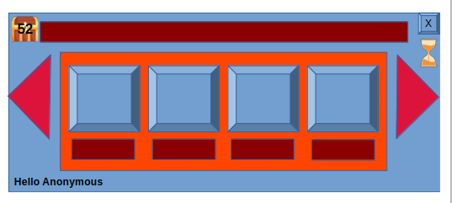
"DefaultAnswerButton" // will hold default definition for answer buttons (defaults for G,H),
(see explanation how we gather all element relevant params for an actual button in Apeendix B)
"MainButtons" is a set of button object IDS that participate in this screen (G,H) the order of buttons in this set will determine the order on screen (“001” will be the first most left button, “002” will be the one right to it etc..), keep in mind that if "MainButtons" contains 3 buttons IDS and not 4 screen will look like this:
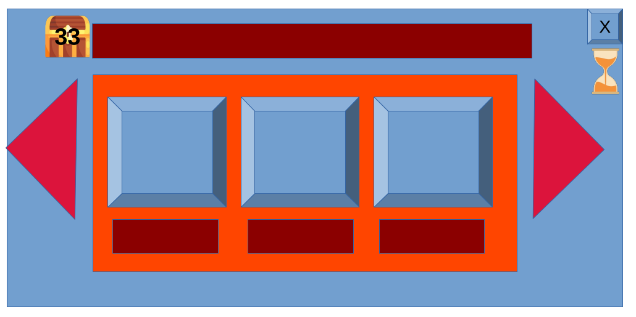

this page contains these elements (from up left to bottom right)
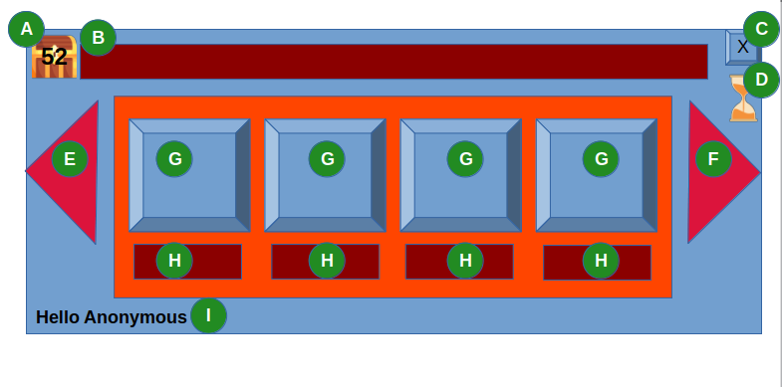
a – a user point indication (treasurebox)
b – Page header
c – Close this page button X)
d – page time left indication (sandwatch)
e – prev button
f – next button
g – question button
h – question text
I – prompt user name text

according to "Object_Type" :(i.e "ButtonPage") program will arrange the elements on screen,

(A) Current User point – reservedword ^Q
(B) PageHeader - a TextHeader element displays the text as in "PageHeader"."Text"
(C) a button to close the program screen. (quick exit)
(D) Display a sandwactch (or second countdown) (initial value can be found in "PageTime")
(E) Display the previous Button (as defined in "PrevButton" ) (see appendix B how to build a full element json using the object hierarchy), (please keep in mind that you also need to add the ^X to this url when activated)
(F) Display the next Button (as defined in "NextButton" ) (see appendix B how to build a full element json using the object hierarchy), (please keep in mind that you also need to add the ^X to this url when activated)
(G) create the set of answer buttons (as defined in "MainButtons")
(H) per button put the text as defined in "ButtonText" in each button object.
(I) a Text displaying "BottomText"."Text" + user name (i.e “Hello to ” + “Dirk Gently”)

according to definition of each answer button it will alter the button appearance, for example
this means:

"AnswerButton2" : {
"Object_ID": "33112",
"ParentObjectID" : "246831",
"Object_Media": {
"ImageUrl" : "^I2ndAnswer.gif"
},
"ButtonText" : "this is text2"
},

that the second answer button in the screen will display the image to be found in ^S/2ndAnswer.gif (include ^X parameters), so in our case it translate to:
www.myq.re//mamushka/qa/ImageBank/1stAnswer.gif?V=1.8&UID=3984344&SID=656522243
on the button surface (G) and the text found in key "ButtonText" ( "this is text2") in the second button text line (H)

RateByPalm
GemBerry-2ndSscreen-C1 - you can see updated json here and in Appendix S2
Program will build the page for display and update all JSON keys according to sequence.
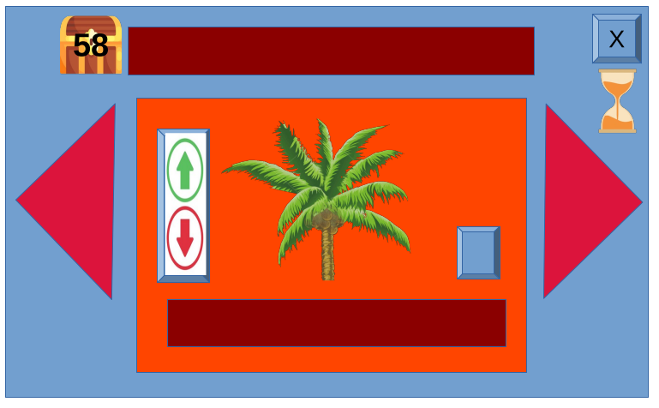

This page displays a single
value select element. And
gives the user an option to
upload his own media to
server using the upload
button.
When screen ends the
Object_index_Value will be
changed upon user selection
and saved in result json.

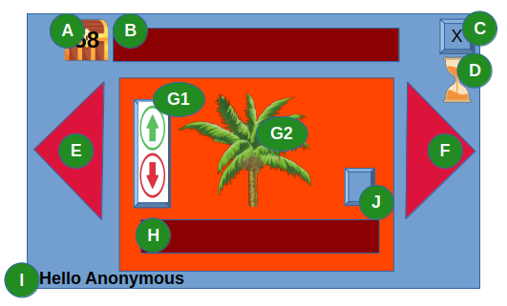
Extra keys relevant to this page
(G) "RateButton" - defintion of the rate button
(J) "UploadButton" – a button to upload user response

RateButton have 3 main elements
G1 – a ruller allows to go up/down to define index value
G2 – a set of images replacing by Button index value
H – Text displayed (The text Value by index from "Object_Optional_Values"

"Rate images" – the set of images to be replaced by value
"Object_index_Value" – Current value (as defined by ruller)
"Object_Optional_Values" – The text to be displayed on Button text (H) by index value.

UploadButton is a simple button that opens the upload page url, allows user to upload his response or upload an image to the server. When upload page is closed it returns to this page

all other activates are as defined in 1stScreenQuestions.
RateTheSpirit
GemBerry-3rdScreen-C1 - you can see updated json here and in Appendix S3
Program will build the page for display and update all JSON keys according to sequence.
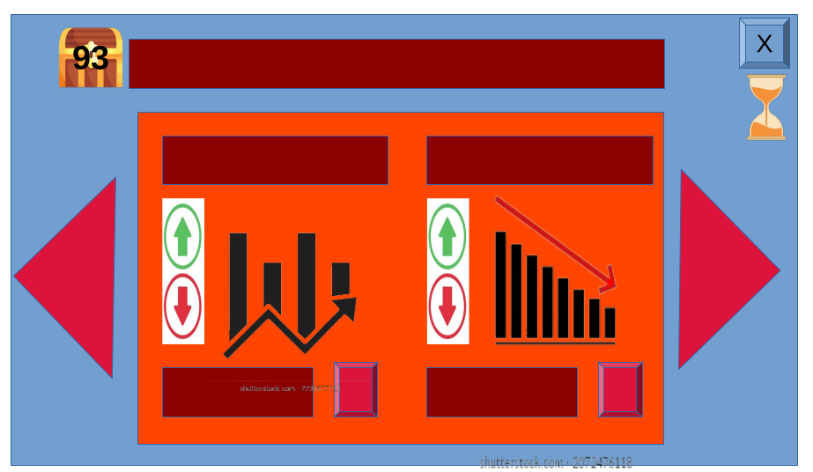
This page displays two
value select element. And
gives the user an option to
upload his own media to
server per each of them
using the upload button of each
element.
When screen ends the
Object_index_Value per element will be changed upon user selection
and saved in result json.

Extra elements relevant to this page
(R0) "RateButton1"."ButtonText"
(R1) The ruller controls on "RateButton1"."Object_index_Value"
(R2) The text Value by index from "Object_Optional_Values"
(R3) "UploadButton" – a button to upload user response
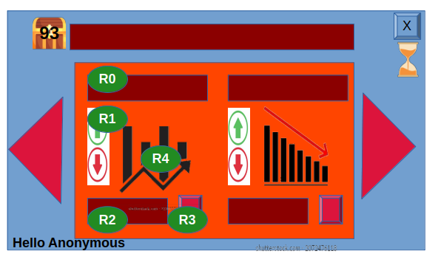
(R4) a set of images replacing by Button index value

Same is applied for the second rate element
"RateButton2".
RateTheSmell
GemBerry-4thScreen-C1 - you can see updated json here and in Appendix S4
Program will build the page for display and update all JSON keys according to sequence.

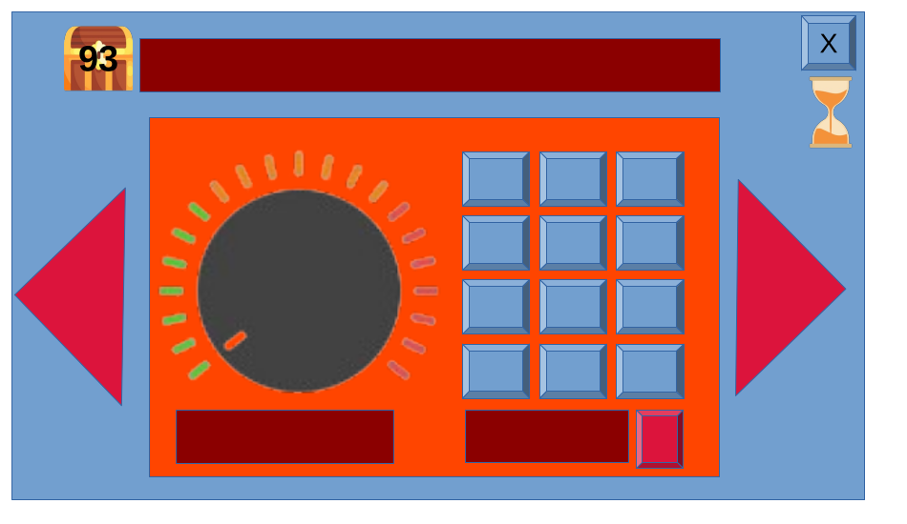
This page displays a round selection
element (1..8 values)
per value there are a set of
small buttons to be displayed.
Screen also gives the user an option to
upload his own media to
server using the upload button

When screen ends the
Object_index_Value will hold the
"RoundRateButton" value and the
"Object_second_Value" will hold the
SmallButton value as defined in
"ValuesButtonSets". For example, if RoundRateButton was selected on value "3" , the screen will draw the buttons that their IDs are defined in "ValuesButtonSets" value “3”
"3" : {
"001": "36032",
"002" :"36033",
"003": "36034",
"004": "36035",
"005": "36036"
},
and then the 4th small button was clicked ( "004": "36035") it will set "Object_second_Value" : “004”.
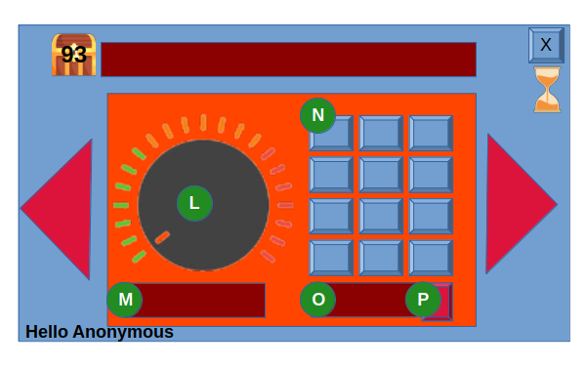
Extra elements relevant to this page
(L) "RoundRateButton"
(M) write the text upon index selection as defined in
"RoundRateButton"."Object_Optional_Values"
(N) a set of small buttons upon index selection as defined in
"ValuesButtonSets"
(O) the "ButtonText" of the pressed small button
(i.e "SmallButton-1-2"."ButtonText" : "S 1-2")
(P) "UploadButton" – a button to upload user response

UserSelectAnswerPage
GemBerry-5thScreen-C1 - you can see updated json here and in Appendix S5
Program will build the page for display and update all JSON keys according to sequence.

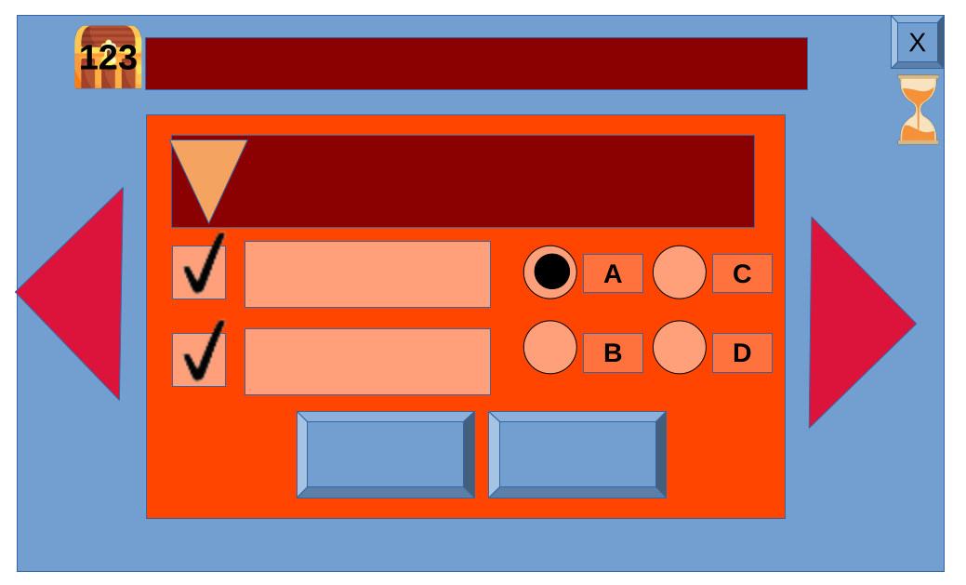
This page displays a set of selection
elements for the user (dropdown,
chekboxes, radiobox)
When screen ends the
Object_index_Value of each element
will hold the selected value.

Pls keep in mind that the number of
Checkbox and radiobuttons on screen
depends on the definition in json, so
if in json we define a set of 5 checkbox
screen will display 5 checkboxes
instead of 2 as shown in the sample.

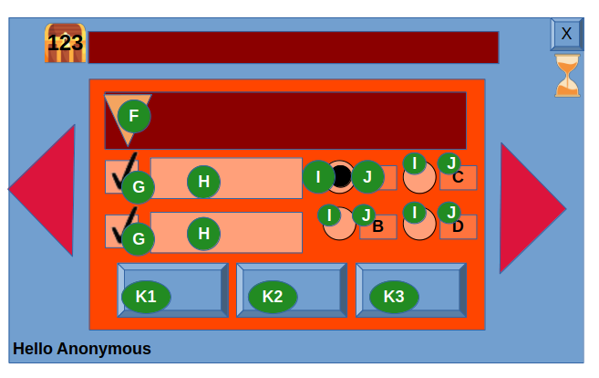
Extra elements relevant to this page
(F) "SelectionList" – definition of list values.
(G) a set of checkbox as defined in "CheckBoxList", each
checkbox can hold “F” or “T”
(i.e "CheckBox2" ."Object_index_Value": "T")
(H) the checkbox defined text "CheckBox2" .”Text”
(I) a set of radio buttons as defined in ""RadioButtonList",
each radiobox can hold “F” or “T” , please keep in mind
that only one radiobutton in the set can be “T” and the
RadioButtonList"."Set_index_Value" will be holding the
va;ue of the radionutton that is “T”.
(J) the radiobutton defined text (i.e "RadioButton2" .”Text”)
(K) set of buttons as defined in "MainButtons" , Pls keep in mind that the number of
Response buttons on screen depends on the definition in json, so if in json we define a set of 3 buttons in "MainButtons" screen will display 3 buttons on screen bottom instead of 2.

UserSelectAnswerPage
GemBerry-6thScreen-C1 - you can see updated json here and in Appendix S6
Program will build the page for display and update all JSON keys according to sequence.
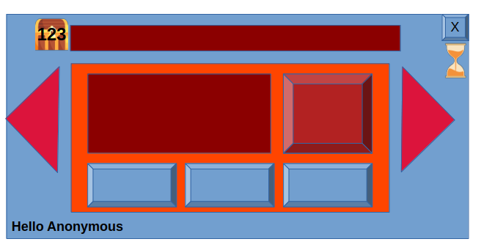
This Page gets user text
response (free text) and allows
user also to add a personal
uploaded image to response

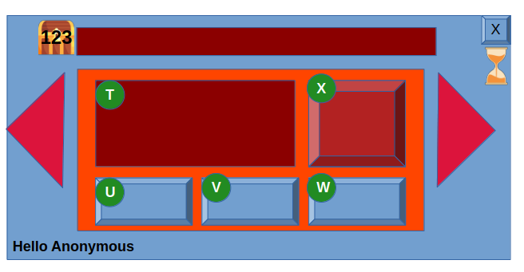
Extra elements relevant to this page
(T) "ResponseText" – textbox, keep in mind that if no
“rtl” is defined, it will use the default page “rtl”
(U,V,W) buttons as defined in "MainButtons",keep in
mind that the number of Response buttons on screen
depends on the definition in json.
In case one of the response button is "upload" it will
act as (X), image will be displayed on (X) button only.
(X) "ImageDisplayUploadButton" – will display the image
as defined in "ImageDisplayUploadButton"."ImageUrl"
whenever user will upload a new image to server,
"ImageUrl" will be updated and image will be displayed.

UserUploadImagePage
GemBerry-uploadImage-C1 - you can see updated json

Appendix A
– User Data to get from browser

Data Element | Description
IP Address | The IP address of the user's device.
Browser Type | The type and version of the web browser used.
Operating System | The operating system and its version on the device.
Screen Resolution | The screen resolution of the user's device.
User Agent | A string that contains information about the browser, OS, and device.
Cookies | Data stored in cookies, including session and tracking information.
Referrer URL | The URL of the page that referred the user to the current page.
Device Type | Whether the user is on a mobile device, tablet, or desktop.
Language | The preferred language settings of the user's browser.
Time Zone | The time zone settings of the user's device.
Geolocation | The geographical location of the user (if permissions are granted).
Local Storage | Data stored in the browser's local storage.
Session Storage | Data stored in the browser's session storage.
Network Type | Information about the type of network connection (WiFi, 4G, etc.).
Battery Status | Information about the device's battery status (if permissions are granted).
Touch Support | Indicates if the device supports touch events.
Online Status | Indicates whether the user is online or offline.
Plugins | Information about installed browser plugins.
Page Load Time | Time taken to load the current page.
Form Data | Data entered by the user in form fields on the web page.
Click Events | Data about the user's interactions with clickable elements.
Scroll Depth | How far the user has scrolled down the page.
Focus/Blur Events | Whether the user is actively viewing the web page or not.
Mouse Position | The position of the mouse cursor on the screen.
Touch Events | Data about touch interactions on touch-enabled devices.
Viewport Size | The visible area of a web page in the user's browser window.

Data will be kept in a json structure (see sample)
sample JS code to collect this data can be found here

Appendix B
Object Building Sample by Hierarchy

if we have this definition in our page JSON (JSON_Version=1.8)

"DefaultAnswerButton": {
"Object_ID": "246831",
"Object_Type": "SimplePressButton",
"XSize": "100%",
"Object_Media": {
"click-sound" : "^Aclick.mp3",
"idle": "^IPanelButtonIdle.gif",
"hover": "^IPanelButtonHoover.gif",
"press": "^IPanelButtonPress.gif"
},
"Object_Optional_Values" : {"1":"Select","2":"UnSelect"},
"Object_index_Value" : "2"
},
"AnswerButton1" : {
"Object_ID": "33112",
"ParentObjectID" : "246831",
"Object_Media": {
"ImageUrl" : "^S/1stAnswer.gif"
},
"ButtonText" : "this is text1"
},

We need to draw the 1st AnswerButton on our page Button
"AnswerButton1"."ParentObjectID" = "246831"
so we go to object ID "246831" (if defined in current JSON, if not we address DB to get it)
There we find "Object_Type" = "SimplePressButton", we go to OBJECTS table and get the relevant json (see sample sql here)

This is the JSON we got for SimplePressButton default definitions

"SimplePressButton": {
"Object_ID": "9900001011",
"ObjectName": "SimplePressButton",
"Object_Parent": "SimpleButton",
"Object_Media": {
"click-sound" : "click.mp3",
"idle": "SimplePressButtonIdle.gif",
"press": "SimplePressButtonPress.gif",
"hoover" : "SimplePressButtonHoover.gif"
},
"UrlToJump" : "www.google.com/?SID=^S"
},
since SimplePressButton."Object_Parent" = "SimpleButton"
we do the same process again for SimpleButton and get this JSON
"SimpleButton": {
"Object_ID": "9900001001",
"ObjectName": "SimpleButton",
"Object_Parent": "Object",
"Object_Media": " { idle : idle image URL, press : Pressed button animated gif... ImageURL : a url for image to display upon button }",
"Object_Optional_Values": "(inside : list of values, here the 10th is the actual button value.if index = 2 than we will have yes/no button)",
"Object_index_Value": "10",
"ButtonText" : "text to display with button"
},

since SimpleButton."Object_Parent" = "Object"
we do the same process again for Object and get this JSON
"Object": {
"Object_ID": "9900000001",
"ObjectName": "Object",
"Object_Parent": "",
"Parent_Object_iD": "",
"Object_Type": "Object"
},
until Object_Parent is empty.

So Final JSON with all params needed to display AnswerButton1 will look like this: (I used colors to show keys origin)

"AnswerButton1" : {
"Object_ID": "33112",
"ParentObjectID" : "246831",
"XSize": "100%",
"Object_Type": "SimplePressButton",
"Object_Media": {
"click-sound" : "^Aclick.mp3",
"idle": "^IPanelButtonIdle.gif",
"hover": "^IPanelButtonHoover.gif",
"press": "^IpanelButtonPress.gif",
"ImageUrl" : "^S/1stAnswer.gif"
},
"ButtonText" : "this is text1"
"Object_Optional_Values" : {"1":"Select","2":"UnSelect"},
"Object_index_Value" : "2"
"UrlToJump" : "www.google.com/?SID=^S"
}

Appendix S0

{
"JSON_id": "GemBerry-ScreenSequence-C1",
"JSON_Version": "1.8",
"Object_ID" : "626119995",
"Object_Type" : "ScreenSequence",
"Object_Name" : "A1-ScreenSequence",
"Screen-Rtl" : "rtl",

"Rserved_Words": {
"^M": "https://myq.re/mamushka/qa/",
"^I": "^M/ImageBank/",
"^A": "^M/AudioBank/",
"^S": "^I656522243",
"^U": "" },
"URLSet": {
"nextURL": "myq.re/DefaultUrls/next?SID=^S",
"prevURL": "myq.re/DefaultUrls/prev?SID=^S",
"uploadURL": "myq.re/DefaultUrls/upload?SID=^S"
},
"CanDisplay" : "landscape",
"ScreensSet" : {
"001": "656574743",
"002" :"656574744",
"003": "656574725",
"004": "656574345",
"005": "656522236",
"006": "656522224"
}

}

Appendix S1
{
"JSON_id": "GemBerry-1stScreen-C1",
"JSON_Version": "1.8",
"Object_ID" : "656574743",
"Object_Type" : "ButtonPage",
"Object_Name" : "1stScreenQuestions",
"Screen-Rtl" : "rtl",

"Rserved_Words": {
"^S": "00000",
"^P": "a reserved word for media definition from page object",
"^U": "Current User ID" },

"URLSet": {
"nextURL": "myq.re/DefaultUrls/next",
"prevURL": "myq.re/DefaultUrls/prev",
"uploadURL" : "myq.re/UploadImageToUserFolder&Source=RatePage"
},
"CanDisplay" : "landscape",
"PageTime" : "45",

"DefaultAnswerButton": {
"Object_ID": "246831",
"Object_Type": "SimplePressButton",
"XSize": "100%",
"Object_Media": {
"click-sound" : "^Aclick.mp3",
"idle": "^IPanelButtonIdle.gif",
"hover": "^IPanelButtonHoover.gif",
"press": "^IPanelButtonPress.gif"
},
"Object_Optional_Values" : {"1":"Select","2":"UnSelect"},
"Object_index_Value" : "2"
},
"PageHeader" : {
"Text" : "The main Question text",
"Text HTML features" : {"Color" : "#ffff", "Font" : "Sans"}
},
"MainButtons" : {
"Object_ID": "8842",
"Object_Type": "ButtonSet",
"ObjectIDSet": {
"001": "33112",
"002" :"33113",
"003": "33114",
"004": "33115"
}
},

"AnswerButton1" : {
"Object_ID": "33112",
"ParentObjectID" : "246831",
"Object_Media": {
"ImageUrl" : "^S/1stAnswer.gif"
},
"ButtonText" : "this is text1"
},
"AnswerButton2" : {
"Object_ID": "33112",
"ParentObjectID" : "246831",
"Object_Media": {
"ImageUrl" : "^S/2ndAnswer.gif"
},
"ButtonText" : "this is text2"
},
"AnswerButton3" : {
"Object_ID": "33113",
"ParentObjectID" : "246831",
"Object_Media": {
"ImageUrl" : "^S/3rdAnswer.gif"
},
"ButtonText" : "this is text3"
},
"AnswerButton4" : {
"Object_ID": "33114",
"ParentObjectID" : "246831",
"Object_Media": {
"ImageUrl" : "^S/4thtAnswer.gif"
},
"ButtonText" : "this Is text4"
},
"AnswerButton5" : {
"Object_ID": "33115",
"ParentObjectID" : "246831",
"Object_Media": {
"ImageUrl" : "^S/5thtAnswer.gif"
},
"ButtonText" : "this Is text5"
}
}

Appendix S2
{
"JSON_id": "GemBerry-2ndSscreen-C1",
"JSON_Version": "1.8",
"Object_ID" : "656574744",
"Object_Type" : "RatePage",
"Object_Name" : "RateByPalm",
"Screen-Rtl" : "rtl",

"Rserved_Words": {
"^S": "656574743",
"^P": "a reserved word for media definition from page object",
"^U": "Current User ID" },

"URLSet": {
"nextURL": "myq.re/DefaultUrls/next",
"prevURL": "myq.re/DefaultUrls/prev",
"uploadURL" : "myq.re/UploadImageToUserFolder&Source=RatePage"
},
"CanDisplay" : "landscape",
"PageTime" : "33",
"MediaSets": {
"Texts": {
"MainQuestion": "איך הראש אחי ?"
}
},
"PageHeader" : {
"Text" : "^PMainQuestion",
"Text HTML features" : {"Color" : "#ffff", "Font" : "Sans"}
},

"RateButton": {
"Object_ID": "246911",
"Object_Type": "SimplePressButton",
"XSize": "100%",
"Object_Media": {
"click-sound" : "^Aclick.mp3",
"Rate images" : {
"1" : "^IRatePalm1.gif",
"2" : "^IRatePalm2.gif",
"3" : "^IRatePalm3.gif",
"4" : "^IRatePalm4.gif",
"5" : "^IRatePalm5.gif",
"6" : "^IRatePalm6.gif",
"7" : "^IRatePalm7.gif",
"8" : "^IRatePalm8.gif"
}
},
"Object_Optional_Values" : {"1":"light","2":"a bit","3" : "does the work", "4" : "Heavy"},
"Object_index_Value" : "3"
},

"UploadButton": {
"Object_ID": "246912",
"Object_Type": "SimplePressButton",
"XSize": "100%",
"Object_Media": {
"click-sound" : "^Aclick.mp3",
"idle": "^IUploadButtonIdle.gif",
"hover": "^IUploadButtonHoover.gif",
"press": "^IUploadButtonPress.gif"
},
"UrlToJump" : "uploadURL"
}
}

Appendix S3
{
"JSON_id": "GemBerry-3rdScreen-C1",
"JSON_Version": "1.8",
"Object_ID" : "656574725",
"Object_Type" : "RatePage",
"Object_Name" : "RateTheSpirit",
"Screen-Rtl" : "rtl",

"URLSet": {
"uploadURL" : "myq.re/UploadImageToUserFolder"
},
"CanDisplay" : "landscape",
"PageTime" : "45",

"MediaSets": {
"Texts": {
"MainQuestion": "והרוח והגוף ?",
"RateButton1Question": "הרוח ?",
"RateButton2Question": "הגוף ?"
}
},

"RateButton1": {
"Object_ID": "246851",
"Object_Type": "SimpleRateButton",
"XSize": "100%",
"ButtonText" : "^PRateButton1Question",
"Object_Media": {
"click-sound" : "^Aclick.mp3",
"Rate images" : {
"1" : "^IRateGraph1.gif",
"2" : "^IRateGraph2.gif",
"3" : "^IRateGraph3.gif",
"4" : "^IRateGraph4.gif",
"5" : "^IRateGraph5.gif",
"6" : "^IRateGraph6.gif",
"7" : "^IRateGraph7.gif",
"8" : "^IRateGraph8.gif"
}
},

"Object_Optional_Values" : {"1":"אוורירי","2":"מרחפת","3" : "מתמוגגת", "4" : "מתפוגגת"},
"Object_index_Value" : "3"
},

"UploadButton1": {
"Object_ID": "246912",
"Object_Type": "SimplePressButton",
"XSize": "100%",
"Object_Media": {
"click-sound" : "^Aclick.mp3",
"idle": "^IUploadButtonIdle.gif",
"hover": "^IUploadButtonHoover.gif",
"press": "^IUploadButtonPress.gif"
},
"UrlToJump" : "uploadURL+ &Source=UploadButton1"
},
"RateButton2": {
"Object_ID": "246852",
"Object_Type": "SimplePressButton",
"XSize": "100%",
"ButtonText" : "^PRateButton2Question",
"Object_Media": {
"click-sound" : "^Aclick.mp3",
"Rate images" : {
"1" : "^IRateGraph1.gif",
"2" : "^IRateGraph2.gif",
"3" : "^IRateGraph3.gif",
"4" : "^IRateGraph4.gif",
"5" : "^IRateGraph5.gif",
"6" : "^IRateGraph6.gif",
"7" : "^IRateGraph7.gif",
"8" : "^IRateGraph8.gif"
}
},

"Object_Optional_Values" : {"1":"או2ורירי","2":"מרח2פת","3" : "מתמ2וגגת", "4" : "מתפ2וגגת"},
"Object_index_Value" : "2"
},
"UploadButton2": {
"Object_ID": "246913",
"Object_Type": "SimplePressButton",
"XSize": "100%",
"Object_Media": {
"click-sound" : "^Aclick.mp3",
"idle": "^IUploadButtonIdle.gif",
"hover": "^IUploadButtonHoover.gif",
"press": "^IUploadButtonPress.gif"
},
"UrlToJump" : "uploadURL+ &Source=UploadButton2"
},
"PageHeader" : {
"Object_ID": "33301",
"Object_Type": "TextHeader",
"Text" : "The main Question text",
"RunType" : "steady",
"Text HTML deatures" : "#Color #Font etc.." }}
Appendix S4

{
"JSON_id": "GemBerry-4thScreen-C1",
"JSON_Version": "1.8",
"Object_ID" : "656574345",
"Object_Type" : "RatePage",
"Object_Name" : "RateTheSmell",
"Screen-Rtl" : "rtl",

"Rserved_Words": {
"^S": "00000",
"^P": "a reserved word for media definition from page object",
"^U": "Current User ID" },

"URLSet": {
"uploadURL" : "myq.re/UploadImageToUserFolder&Source=RatePage"
},
"CanDisplay" : "landscape",
"PageTime" : "60",
"MediaSets": {
"Texts": {
"MainQuestion": "איך הריח ?"
}
},

"RoundRateButton": {
"Object_ID": "277851",
"Object_Type": "RoundRateButton",
"XSize": "100%",
"Object_Media": {
"click-sound" : "^Aclick.mp3",
"Rate images" : {
"1" : "^IRoundRate1.gif",
"2" : "^IRoundRate2.gif",
"3" : "^IRoundRate3.gif",
"4" : "^IRoundRate4.gif",
"5" : "^IRoundRate5.gif",
"6" : "^IRoundRate6.gif",
"7" : "^IRoundRate7.gif",
"8" : "^IRoundRate8.gif"
}
},

"Object_Optional_Values" :
{"1":"הדרי",
"2" :"פירותי",
"3" : "אדמה",
"4" : "אורן",
"5" : "אור2ן",
"6" : "אור3ן",
"7" : "אור4ן"
},

"Object_index_Value" : "2",
"Object_second_Value" : "0",

"ValuesButtonSets" : {
"1" : {
"001": "36012",
"002" :"36013",
"003": "36014",
"004": "36015"
},
"2" : {
"001": "36022",
"002" :"36023",
"003": "36024",
"004": "36025",
"005": "36026"
},
"3" : {
"001": "36032",
"002" :"36033",
"003": "36034",
"004": "36035",
"005": "36036"
},
"4" : {
"001": "36042",
"002" :"36043",
"003": "36044",
"004": "36045",
"005": "36046"
},
"5" : {
"001": "36052",
"002" :"36053",
"003": "36054",
"004": "36055",
"005": "36056"
},
"6" : {
"001": "36032",
"002" :"36063",
"003": "36064",
"004": "36065",
"005": "36066"
},
"7" : {
"001": "36072",
"002" :"36073",
"003": "36074",
"004": "36075",
"005": "36076"
},
"8" : {
"001": "36082",
"002" :"36083",
"003": "36084",
"004": "36085",
"005": "36086",
"006": "36026"
}
}},

"UploadButton": {
"Object_ID": "246883",
"Object_Type": "SimplePressButton",
"XSize": "100%",
"Object_Media": {
"click-sound" : "^Aclick.mp3",
"idle": "^IUploadButtonIdle.gif",
"hover": "^IUploadButtonHoover.gif",
"press": "^IUploadButtonPress.gif"
},
"UrlToJump" : "^PuploadURL+ &Source=RoundRate &Value=^PObject_index_Value"
},

"PageHeader" : {
"Object_ID": "33301",
"Object_Type": "TextHeader",
"Text" : "The main Question text",
"RunType" : "steady",
"Text HTML deatures" : "#Color #Font etc.."
},

"SimpleSmallButton": {
"Object_ID": "9800001001",
"ObjectName": "SimplePressButton",
"Object_Parent": "SimpleButton",
"Object_Media": {
"click-sound" : "click.mp3",
"idle": "SimplePressButtonIdle.gif",
"press": "SimplePressButtonPress.gif",
"hoover" : "SimplePressButtonHoover.gif"
}

},

"SmallButton-1-1" : {
"Object_ID": "36012",
"ParentObjectID" : "9800001001",
"Object_Media": {
"ImageUrl" : "^S/Smells/Smell-1-1.gif"
},
"ButtonText" : "S 1-1"
},

"SmallButton-1-2" : {
"Object_ID": "36013",
"ParentObjectID" : "9800001001",
"Object_Media": {
"ImageUrl" : "^S/Smells/Smell-1-2.gif"
},
"ButtonText" : "S 1-2"
},
"SmallButton-1-3" : {
"Object_ID": "36014",
"ParentObjectID" : "9800001001",
"Object_Media": {
"ImageUrl" : "^S/Smells/Smell-1-3.gif"
},
"ButtonText" : "S 1-3"
},

"SmallButton-1-4" : {
"Object_ID": "36015",
"ParentObjectID" : "9800001001",
"Object_Media": {
"ImageUrl" : "^S/Smells/Smell-1-4.gif"
},
"ButtonText" : "S 1-4"
},
"SmallButton-2-1" : {
"Object_ID": "36022",
"ParentObjectID" : "9800001001",
"Object_Media": {
"ImageUrl" : "^S/Smells/Smell-2-1.gif"
},
"ButtonText" : "S 2-1"
},

"SmallButton-2-2" : {
"Object_ID": "36023",
"ParentObjectID" : "9800001001",
"Object_Media": {
"ImageUrl" : "^S/Smells/Smell-2-2.gif"
},
"ButtonText" : "S 2-2"
},
"SmallButton-2-3" : {
"Object_ID": "36024",
"ParentObjectID" : "9800001001",
"Object_Media": {
"ImageUrl" : "^S/Smells/Smell-2-3.gif"
},
"ButtonText" : "S 2-3"
},

"SmallButton-2-4" : {
"Object_ID": "36025",
"ParentObjectID" : "9800001001",
"Object_Media": {
"ImageUrl" : "^S/Smells/Smell-2-4.gif"
},
"ButtonText" : "S 2-4"
},

"SmallButton-2-5" : {
"Object_ID": "36026",
"ParentObjectID" : "9800001001",
"Object_Media": {
"ImageUrl" : "^S/Smells/Smell-2-5.gif"
},
"ButtonText" : "S 2-5"
},
"SmallButton-3-1" : {
"Object_ID": "36032",
"ParentObjectID" : "9800001001",
"Object_Media": {
"ImageUrl" : "^S/Smells/Smell-3-1.gif"
},
"ButtonText" : "S 3-1"
},

"SmallButton-3-2" : {
"Object_ID": "36033",
"ParentObjectID" : "9800001001",
"Object_Media": {
"ImageUrl" : "^S/Smells/Smell-3-2.gif"
},
"ButtonText" : "S 3-2"
},
"SmallButton-3-3" : {
"Object_ID": "36034",
"ParentObjectID" : "9800001001",
"Object_Media": {
"ImageUrl" : "^S/Smells/Smell-3-3.gif"
},
"ButtonText" : "S 3-3"
},

"SmallButton-3-4" : {
"Object_ID": "36035",
"ParentObjectID" : "9800001001",
"Object_Media": {
"ImageUrl" : "^S/Smells/Smell-3-4.gif"
},
"ButtonText" : "S 3-4"
},

"SmallButton-3-5" : {
"Object_ID": "36036",
"ParentObjectID" : "9800001001",
"Object_Media": {
"ImageUrl" : "^S/Smells/Smell-3-5.gif"
},
"ButtonText" : "S 3-5"
},
"SmallButton-4-1" : {
"Object_ID": "36042",
"ParentObjectID" : "9800001001",
"Object_Media": {
"ImageUrl" : "^S/Smells/Smell-4-1.gif"
},
"ButtonText" : "S 4-1"
},

"SmallButton-4-2" : {
"Object_ID": "36043",
"ParentObjectID" : "9800001001",
"Object_Media": {
"ImageUrl" : "^S/Smells/Smell-4-2.gif"
},
"ButtonText" : "S 4-2"
},
"SmallButton-4-3" : {
"Object_ID": "36044",
"ParentObjectID" : "9800001001",
"Object_Media": {
"ImageUrl" : "^S/Smells/Smell-4-3.gif"
},
"ButtonText" : "S 4-3"
},

"SmallButton-4-4" : {
"Object_ID": "36045",
"ParentObjectID" : "9800001001",
"Object_Media": {
"ImageUrl" : "^S/Smells/Smell-4-4.gif"
},
"ButtonText" : "S 4-4"
},

"SmallButton-4-5" : {
"Object_ID": "36046",
"ParentObjectID" : "9800001001",
"Object_Media": {
"ImageUrl" : "^S/Smells/Smell-4-5.gif"
},
"ButtonText" : "S 4-5"
},
"SmallButton-5-1" : {
"Object_ID": "36052",
"ParentObjectID" : "9800001001",
"Object_Media": {
"ImageUrl" : "^S/Smells/Smell-5-1.gif"
},
"ButtonText" : "S 5-1"
},

"SmallButton-5-2" : {
"Object_ID": "36053",
"ParentObjectID" : "9800001001",
"Object_Media": {
"ImageUrl" : "^S/Smells/Smell-5-2.gif"
},
"ButtonText" : "S 5-2"
},
"SmallButton-5-3" : {
"Object_ID": "36054",
"ParentObjectID" : "9800001001",
"Object_Media": {
"ImageUrl" : "^S/Smells/Smell-5-3.gif"
},
"ButtonText" : "S 5-3"
},

"SmallButton-5-4" : {
"Object_ID": "36055",
"ParentObjectID" : "9800001001",
"Object_Media": {
"ImageUrl" : "^S/Smells/Smell-5-4.gif"
},
"ButtonText" : "S 5-4"
},

"SmallButton-5-5" : {
"Object_ID": "36056",
"ParentObjectID" : "9800001001",
"Object_Media": {
"ImageUrl" : "^S/Smells/Smell-5-5.gif"
},
"ButtonText" : "S 5-5"
},
"SmallButton-6-1" : {
"Object_ID": "36062",
"ParentObjectID" : "9800001001",
"Object_Media": {
"ImageUrl" : "^S/Smells/Smell-6-1.gif"
},
"ButtonText" : "S 6-1"
},

"SmallButton-6-2" : {
"Object_ID": "36063",
"ParentObjectID" : "9800001001",
"Object_Media": {
"ImageUrl" : "^S/Smells/Smell-6-2.gif"
},
"ButtonText" : "S 6-2"
},
"SmallButton-6-3" : {
"Object_ID": "36064",
"ParentObjectID" : "9800001001",
"Object_Media": {
"ImageUrl" : "^S/Smells/Smell-6-3.gif"
},
"ButtonText" : "S 6-3"
},

"SmallButton-6-4" : {
"Object_ID": "36065",
"ParentObjectID" : "9800001001",
"Object_Media": {
"ImageUrl" : "^S/Smells/Smell-6-4.gif"
},
"ButtonText" : "S 6-4"
},

"SmallButton-6-5" : {
"Object_ID": "36066",
"ParentObjectID" : "9800001001",
"Object_Media": {
"ImageUrl" : "^S/Smells/Smell-6-5.gif"
},
"ButtonText" : "S 6-5"
},
"SmallButton-7-1" : {
"Object_ID": "36072",
"ParentObjectID" : "9800001001",
"Object_Media": {
"ImageUrl" : "^S/Smells/Smell-7-1.gif"
},
"ButtonText" : "S 7-1"
},

"SmallButton-7-2" : {
"Object_ID": "36073",
"ParentObjectID" : "9800001001",
"Object_Media": {
"ImageUrl" : "^S/Smells/Smell-7-2.gif"
},
"ButtonText" : "S 7-2"
},
"SmallButton-7-3" : {
"Object_ID": "36074",
"ParentObjectID" : "9800001001",
"Object_Media": {
"ImageUrl" : "^S/Smells/Smell-7-3.gif"
},
"ButtonText" : "S 7-3"
},

"SmallButton-7-4" : {
"Object_ID": "36075",
"ParentObjectID" : "9800001001",
"Object_Media": {
"ImageUrl" : "^S/Smells/Smell-7-4.gif"
},
"ButtonText" : "S 7-4"
},

"SmallButton-7-5" : {
"Object_ID": "36076",
"ParentObjectID" : "9800001001",
"Object_Media": {
"ImageUrl" : "^S/Smells/Smell-7-5.gif"
},
"ButtonText" : "S 7-5"
},
"SmallButton-8-1" : {
"Object_ID": "36082",
"ParentObjectID" : "9800001001",
"Object_Media": {
"ImageUrl" : "^S/Smells/Smell-8-1.gif"
},
"ButtonText" : "S 8-1"
},

"SmallButton-8-2" : {
"Object_ID": "36083",
"ParentObjectID" : "9800001001",
"Object_Media": {
"ImageUrl" : "^S/Smells/Smell-8-2.gif"
},
"ButtonText" : "S 8-2"
},
"SmallButton-8-3" : {
"Object_ID": "36084",
"ParentObjectID" : "9800001001",
"Object_Media": {
"ImageUrl" : "^S/Smells/Smell-8-3.gif"
},
"ButtonText" : "S 8-3"
},

"SmallButton-8-4" : {
"Object_ID": "36085",
"ParentObjectID" : "9800001001",
"Object_Media": {
"ImageUrl" : "^S/Smells/Smell-8-4.gif"
},
"ButtonText" : "S 8-4"
},

"SmallButton-8-5" : {
"Object_ID": "36086",
"ParentObjectID" : "9800001001",
"Object_Media": {
"ImageUrl" : "^S/Smells/Smell-8-5.gif"
},
"ButtonText" : "S 8-5"
}

}

Appendix S5

{
"JSON_id": "GemBerry-5thScreen-C1",
"JSON_Version": "1.8",
"Object_ID" : "656522236",
"Object_Type" : "Page",
"Object_Name" : "UserSelectAnswerPage",
"Screen-Rtl" : "rtl",

"URLSet": {
"uploadURL" : "myq.re/UploadImageToUserFolder&Source=UserSelectAnswerPage"

},
"CanDisplay" : "landscape",
"PageTime" : "55",

"SelectionList": {
"Object_ID": "246855",
"Object_Type": "SelectList",
"XSize": "100%",

"Object_Media": {
"click-sound" : "^Aclick.mp3"
},
"Text" : "This is a sample selection list",
"Object_Optional_Values" :
{"1":"AA1י",
"2" :"Bפירותי",
"3" : "Cאדמה",
"4" : "Dאורן",
"5" : "Eאור2ן",
"6" : "Fאור3ן",
"7" : "Gאור4ן"
},
"Object_index_Value": "4"
},

"MainButtons" : {
"Object_ID": "8421",
"Object_Type": "ButtonSet",
"ObjectIDSet": {
"yes": "36152",
"no" :"36153"

}
},
"CheckBoxList" : {
"Object_ID": "8422",
"Object_Type": "ButtonSet",
"ObjectIDSet": {
"1": "36351",
"2" :"36352",
"3" :"36353",
"4" :"36354"
}
},

"RadioButtonList" :{
"Object_ID": "8423",
"Object_Type": "ButtonSet",
"ObjectIDSet": {
"1": "36251",
"2" :"36252"

} },

"ResponseButton1" : {
"Object_ID": "36152",
"ParentObjectID" : "246855",
"Object_Media": {
"ImageUrl" : "^S/Approve.gif"
},
"ButtonText" : "Yes !"
},
"ResponseButton2" : {
"Object_ID": "36153",
"ParentObjectID" : "246855",
"Object_Media": {
"ImageUrl" : "^S/DisApprove.gif"
},
"ButtonText" : "Nop !!"
} ,
"CheckBox1" : {
"Object_ID": "36251",
"Object_Parent": "SingleSelectBox",
"Text" : "Can we Call you ?",
"Object_index_Value": "F"
},
"CheckBox2" : {
"Object_ID": "36252",
"Object_Parent": "SingleSelectBox",
"Text" : "Save your details ?",
"Object_index_Value": "T"
},
"RadioButton1" : {
"Object_ID": "36351",
"Object_Parent": "SingleSelectBox",
"Text" : "A",
"Object_index_Value": "F"
},
"RadioButton2" : {
"Object_ID": "36352",
"Object_Parent": "SingleSelectBox",
"Text" : "B",
"Object_index_Value": "F"
},
"RadioButton3" : {
"Object_ID": "36353",
"Object_Parent": "SingleSelectBox",
"Text" : "C",
"Object_index_Value": "F"
},
"RadioButton4" : {
"Object_ID": "36354",
"Object_Parent": "SingleSelectBox",
"Text" : "D",
"Object_index_Value": "F"
}

}

Appendix S6

{
"JSON_id": "GemBerry-6thScreen-C1",
"JSON_Version": "1.8",
"Object_ID" : "656522224",
"Object_Type" : "RsponsePage",
"Object_Name" : "UserResponse",
"Screen-Rtl" : "rtl",

"CanDisplay" : "landscape",
"PageTime" : "29",

"DefaultRsponseButton": {
"Object_ID": "246855",
"Object_Type": "SimplePressButton",
"XSize": "100%",

"Object_Media": {
"click-sound" : "^Aclick.mp3",
"idle": "^IPanelButtonIdle.gif",
"hover": "^IPanelButtonHoover.gif",
"press": "^IPanelButtonPress.gif"
}
},
"ResponseText" : {
"Text" : "Tell us what u think",
"MaxChars" : "255"
},

"ImageDisplayUploadButton": {
"Object_ID": "246877",
"Object_Type": "SimplePressButton",
"XSize": "100%",
"Object_Media": {
"click-sound" : "^Aclick.mp3",
"idle": "^IImageButtonIdle.gif",
"hover": "^IImageButtonHoover.gif",
"press": "^IImageButtonPress.gif",
"ImageUrl" : "^S/currentResponseImage.gif"
},
"UrlToJump" : "^PuploadURL"

},

"UploadedImageDisplay" : "246877",

"MainButtons" : {
"Object_ID": "8812",
"Object_Type": "ButtonSet",
"ObjectIDSet": {
"yes": "36112",
"no" :"36113",
"upload": "36114"
}
},

"ResponseButton1" : {
"Object_ID": "36112",
"ParentObjectID" : "246855",
"Object_Media": {
"ImageUrl" : "^S/Approve.gif"
},
"ButtonText" : "Yes !"
},
"ResponseButton2" : {
"Object_ID": "36113",
"ParentObjectID" : "246855",
"Object_Media": {
"ImageUrl" : "^S/DisApprove.gif"
},
"ButtonText" : "No !!"
},
"ResponseButton3" : {
"Object_ID": "36114",
"ParentObjectID" : "246855",
"Object_Media": {
"ImageUrl" : "^S/UploadImage.gif"
},
"ButtonText" : "Upload yours"
}
}

